

**NW HOUSTON INSPIRATIONAL WRITERS ALIVE!**

**THE SCRIBE**

***Vol. 7 May 2019 No. 5_____________1 of 5________***

**Inspirational Writers Alive! (IWA!) is a Christian interdenominational writers’ club. IWA! promotes creative writing to glorify Christ by helping individuals advance their writing skills and find effective markets for their work. We welcome writers at all levels. _______________________________________­­­­­­­­­­­­­­­­­­­­___________________________________**

***Where and When NW Houston IWA! Meets***

Second Tuesdays at Copperfield Church,

8350 Hwy. 6 North, 7:00-9:00 p.m.

Check with the reception desk for the IWA! meeting room number.

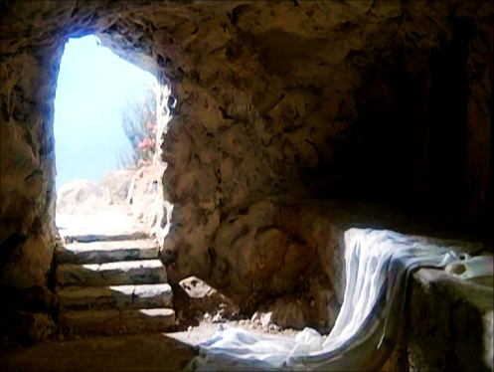  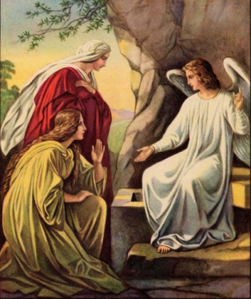

**Join us May 14, 2019**

**for our Critique Meeting**

**and encouragement, inspiration, and advancement of your work-in-progress.**

**Guidelines for a Critique**

**All genre, article,devotionals, fiction, memoirs, non-fiction, poetry, short stories, and screenplays. Please bring six copies, double-spaced, five page limit. Number each copy. We read manuscripts out loud. Readers enter comments, sign, and return manuscipt to author.**

**We welcome visitors with manuscripts at the critique table.**

**Future 2019 Events and Meetings**

**June: Speaker-Janice Thompson – Page 2**

Inspirational Writers Alive! Open Competition 2019 Deadline for entries: June 15, 2019

<http://www.centralhoustoniwa.com/2019_Contest_Registration_Form_IWA.pdf>

**July: Critique Meeting**

**August: Annual Texas Christian Writers Conference sponsored by IWA! – Page 2-4 and**

at <http://www.centralhoustoniwa.com/2019_TCWC_Brochure_revA.pdf>

**JANICE THOMPSON 2**

**SPEAKER**

**NW Houston IWA! Meeting**

**June 11, 2019**

Award-winning author Janice Thompson got her start in the industry writing screenplays and musical comedies for the stage. Janice has published over 110 books for the Christian market, crossing genre lines to write cozy mysteries, historicals, romances, nonfiction books, devotionals, children’s books and more. She particularly enjoys writing light-hearted, comedic tales because she enjoys making readers laugh. Janice is passionate about her faith and does all she can to share the joy of the Lord with others, which is why she particularly enjoys writing. Her tagline, “Love, Laughter, and Happily Ever Afters!” sums up her take on life. She lives in Spring, Texas, where she leads a rich life with her family, a host of writing friends, and three mischievous dogs. When she’s not busy writing or playing with her nine grandchildren, Janice can be found in the kitchen, baking specialty cakes and cookies for friends and loved ones. No matter what she’s cooking up—books, cakes, cookies or mischief—she does her best to keep the Lord at the center of it all. Read more on Janice’s website: <http://janiceathompson.com>

______________________________________________________________________________

**27th Annual**

**Texas Christian Writers’ Conference**

Sponsored by

**Inspirational Writers Alive!**



**Saturday, August 3, 2019**

**8:00 a.m. – 4:15 p.m.**

**Houston’s First Baptist Church**

**7401 Katy Freeway**

**Houston, Texas 77024**



**CONFERENCE REGISTRATION FORM 3**

**Name:** ____________________________________________________________

**Address:** __________________________________________________________

**City**: ____________________________ **State:** __________ **Zip**: _____________

**E-mail:** ___________________________________________________________

**Registration Type/Fee (*please check one*):**

_____ Full Day ***–*** Member: $80

_____ Full Day ***–*** Member (age 55+): $70

_____ Full Day ***–*** Member couple: $125

_____ Full Day ***–*** Non-member: $90

_____ Full Day ***–*** Non-member (age 55+): $80

_____ Full Day ***–*** Non-member couple: $135

_____ Half Day ***–*** Morning (8 a.m. to 12 p.m.): $50

_____ Half Day ***–*** Afternoon (12 p.m. to 4:30 p.m.): $50

_____ Lunch Only* (12 to 1:15 p.m.): $10

 * Individuals wanting to attend only the half day ***–*** morning session or only the awards ceremony may purchase lunch.

* Full day registration includes keynote address, four workshops, continental breakfast, lunch, and snacks.
* Half day morning registration includes keynote address, two workshops, continental breakfast, and snacks.
* Half day afternoon registration includes two workshops, lunch, and snacks.
* Full day and half day registration also includes author chats, faculty books at the conference rate, and a chance to win door prizes including Amazon gift cards, books, and free editing and writing coaching sessions.

Please make your check or money order payable to “TCWC Martha Rogers”. Cash or checks will also be accepted at the door. In addition to the fees listed above for full day and half day registrations, an additional $10 will be charged for walk-ins on the day of the conference. Registration fees are not refundable after July 25. Please mail your completed registration form and payment to Martha Rogers at 6038 Greenmont, Houston, Texas 77092.

**2019 Texas Christian Writers’ Conference 4**

**Saturday, August 3, 2019**

**Houston’s First Baptist Church—7401 Katy Freeway**

**CONFERENCE SCHEDULE**

**8:00–8:30 a.m. Continental Breakfast**

**8:30–8:45 a.m. Welcome and Announcements:** Martha Rogers

**Devotion:** Melanie Stiles

**8:45–9:00 a.m. Break/Bookstore Open\***

**9:00–10:00 a.m. Workshop I (Rooms: A – 252, B – 253, C – 254)**

A. Linda Kozar: *What Nancy Drew Didn’t Teach You About Writing Mysteries*

B. Lena Nelson Dooley: *Layering Pizazz*

C. Donna Pyle: *The Art of Writing Engaging Nonfiction*

**10:00–10:15 a.m. Break/Bookstore Open\***

**10:15–11:15 a.m. Workshop II (Rooms: A – 252, B – 253, C – 254)**

A. Janice Thompson: *The Positive Attribute of Stress*

B. Crystal L. Barnes: *Formatting 101*

C. Martha Rogers: *Showing/Telling - Show what is happening rather than telling your reader*

**11:20 –12:00 p.m. Keynote Address**

Lena Nelson Dooley: *The Wonderful Plans Our Marvelous God Has For Your Life*

**12:00–1:00 p.m. Lunch**

**1:00–1:30 p.m. Break/Bookstore Open\***

1**:30–2:30 p.m. Workshop III (Rooms: A – 252, B – 253, C – 254)**

A. Linda Kozar: *The Power of Podcasting*

B. Crystal L. Barnes: *Cover Design Basics*

C. Melanie Stiles: *Selling Freelance Articles*

**2:30–2:45 p.m. Break/Bookstore Open\***

**2:45–3:45 p.m. Workshop IV (Rooms: A – 252, B – 253, C – 254)**

A. Janice Thompson: *Polishing Your Proposal*

B. Lena Nelson Dooley: *Self-Editing: Getting the Words Right*

C. Donna Pyle: *The Author as a Speaker: Engaging Your Audience*

**3:50–4:15 p.m. Closing Remarks/Announcements/Door Prizes/Evaluations**

**\*** *The bookstore closes at 2:45 p.m.*

**5**



May our NW Houston IWA! 2019 meetings be a source of guidance and inspiration, and

His power and glory abound in all you write in 2019.

15 He sendeth forth his commandment upon earth:

His word runneth very swiftly.

16 He giveth snow like wool:

He scattereth the hoarfrost like ashes.

17 He casteth forth his ice like morsels:

Who can stand before his cold?

18 He sendeth out his word, and melteth.them:

he causeth his wind to blow, and the waters flow.

Psalm 147:15-18 KJV

For more information contact: Martha Roddy, [magnolia7787@gmail.com](mailto:magnolia7787@gmail.com)

Subscribe or unsubscribe: [mdworshak62@gmail.com](mailto:magnolia7787@gmail.com).

**GENERAL INFORMATION**

A Christian interdenominational writers’ club, Inspirational Writers Alive! (IWA!) helps aspiring and published authors advance their writing skills and find effective markets for their work. Maxine E. Holder founded IWA! in March 1990. IWA! members meet monthly to learn from speakers, participate in critique sessions and read-arounds, and network with other writers. IWA! sponsors the annual Texas Christian Writers’ Conference (TCWC).

**IWA! CHAPTERS**

Currently, there are four IWA! Chapters in Texas. If you are interested in joining an existing IWA! chapter, please contact the president listed below. To find out more about starting an IWA! chapter in your area, you may request an information packet at the TCWC or reach out to Martha Rogers at marthalrogers@sbcglobal.net.

* **Amarillo**—Karl Smith ([karlwk@suddenlink.net](mailto:karlwk@suddenlink.net), 806-336-5164)
* **Central Houston**—Diana Battista (loveeternal@comcast.net, 832-315-8430)
* **Northwest Houston**—Martha Roddy ([magnolia77@webtv.com](mailto:magnolia77@webtv.com), 281-859-4208)
* **Pasadena**—Bill Page (713-946-0806)

**WHAT TO BRING TO THE TCWC**

* Notebook and paper for taking notes
* Light wrap or sweater as classrooms may be chilly
* Money or checkbook if you want to purchase books in the bookstore (payment by cash or check only)
* Questions to ask the faculty during author chats throughout the day

**QUESTIONS ABOUT THE TCWC**

* Registration, special dietary needs, etc.
  + Martha Rogers – [marthalrogers@sbcglobal.net](mailto:marthalrogers@sbcglobal.net)
  + Melanie Stiles – [melstiles@aol.com](mailto:melstiles@aol.com)
  + Michelle Marie Hernandez – bella@michellemariehernandez.com

**DIRECTIONS**

* **Eastbound on I-10:** Exit at Post Oak/Silber. Continue on the feeder to the church. Turn right and follow the street around to the south parking lot across from First Baptist Academy. Enter the church through the Fitness and Recreation Center, and follow the signs to the Fellowship Center.
* **Westbound on I-10 East:** Exit at Antoine. Turn left under the freeway and follow the feeder to the church as above.
* **From Loop 610 or 290:** Take I-10 West. Exit at Antoine. Follow the directions listed above.



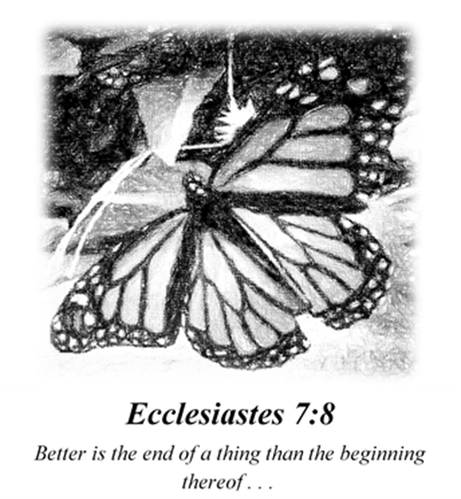

*Though she is but a worm,*

*she spins her silk cocoon and waits,*

*―as if by faith**―*

*beneath the milky-weed.*

*“Better is the end of a thing . . .”* ―Ecc. 7:8

*she sings,*

*while spinning day and night,*

*and night and day.*

*Once safe inside,*

*clothed in humility she waits*

*―like one whose treasure is in Heaven*

*where thieves cannot break in* ―Mt. 6:20.

*Does she dream of monarch wings*

*that she may robe in queenly-gold or royal-red?*

*Or does she know*

*no colored wings dare to compare with wings of faith*

*if she is one of His?* —Eph. 1:6.

*Perhaps the choicest wings await*

*those who believe!*

*—And so, for her,*

***All Things are Possible!***—Mk. 9:23.

M.J. Dworshak