

**NW Houston Inspirational Writers Alive!**

**THE SCRIBE**

**Vol.8 March 2020 No.3____________1 of 3_____**

**Inspirational Writers Alive! (IWA!)**

**is a Christian interdenominational writers’ club. IWA! promotes creative writing to glorifyChrist by helping individuals advance their writing skills and find effective Christian and secular markets for their work.**

**We welcome writers at all levels.**

**NW HOUSTON IWA! MEETS MONTHLY**

**Second Tuesdays at Copperfield Church, 8350 Hwy. 6 North, 7:00-9:00 p.m.**

**Check with the front desk for Room Number**

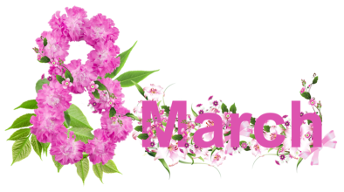

***Join us***

**MARCH 1, 2020**

**CRITIQUE MEETING**

**Bring a work-in progress for critique**

**Follow Guidelines: Double Space, 5 page limit**

**COMING EVENTS**

**April 14, 2020 – Critique Meeting**

**May 12, 2020 – DiAnn Mills, Speaker**

**SAVE THE DATE!**

**Don’t miss our May meeting with DiAnn Mills**

**Topic: “Creating A Powerful Book Launch”**

DiAnn Mills is a bestselling author who believes her readers should expect an adventure. She is a storyteller and creates action-packed, suspense-filled novels to thrill readers. Her titles have appeared on the CBA and ECPA bestseller lists; won two Christy Awards; and been finalists for the RITA, Daphne Du Maurier, Inspirational Readers’ Choice, and Carol award contests. Titles of Published Works – <https://diannmills.com/pdf-downloads/DiAnnMillsBookList.pdf>

DiAnn is a founding board member of the American Christian Fiction Writers, a member of Advanced Writers and Speakers Association, Mystery Writers of America, Sisters in Crime, and International Thriller Writers. She is a director of the Blue Ridge Mountain Christian Writers Conference and focused Mountainside Retreats with social media specialist Edie Melson where she continues her passion of helping other writers be successful. She speaks and teaches writing workshops around the country.

Professional Organizations and other Credits: - as noted in bio above and on this page - <https://diannmills.com/media/>

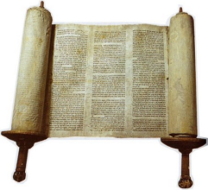  
MORE COMING EVENTS

**June 15**  **IWA! Open Competition 2020 Deadline for entries:**

For more info <http://www.centralhoustoniwa.com/>

**August 1 Texas Chrisitan Writers Conference**

**sponsored by IWA!**

For more info <http://www.centralhoustoniwa.com/>

In August, NW Houston IWA! meets

at Houston’s First Baptist Church for the TCWC

**December 15** Christmas Party

and Christmas Stories Read Around

**Want to be published?** **Submit to the “The Scribe.”**

Guidelines: New Times Roman;12 point Font or Publisher Required Font; Limit 5 pages double spaced lines. Submissions ubject to Editing with Author Review and OK.



The best deal in Houston!

**Annual Dues**

Singles, $20; Seniors, $25; Couples, $35; Associates, $15

See Cherri Taylor, Treasurer, for more details.

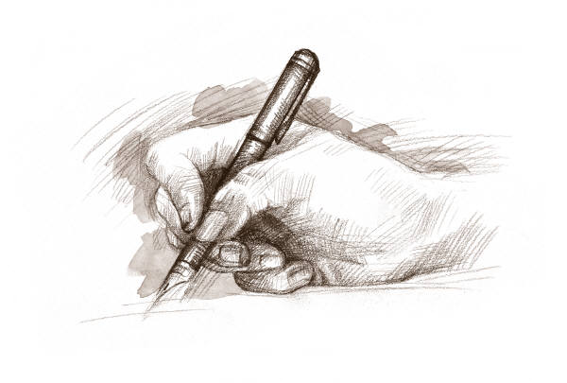

***Helping and encouraging writers and aspiring writers***

***who want to share the love of Jesus Christ***

***through publication of their works in both religious and secular markets.***

15 He sendth forth his commandment upon earth:

His word runneth very swiftly.

16 He giveth snow like wool:

He scattereth the hoarfrost like ashes.

17 He casteth forth his ice like morsels:

Who can stand before his cold?

18 He sendeth out his word, and melteth .them:

he causeth his wind to blow, and the waters flow.

**Psalm 147:15-18 KJV**

**Subscribe or unsubscribe contact: Martha Roddy/magnolia77872gmail.com**