

**NW HOUSTON   
Inspirational Writers Alive!**

**THE SCRIBE**

***Vol.8 June 2020 No.6________________ _1 of 4_***

**Inspirational Writers Alive! (IWA!) is a Christian interdenominational writers’ club. IWA! promotes creative writing to glorify Christ by helping individuals advance their writing skills and find effective Christian and secular markets for their work.**

**We welcome writers at all levels.**

**Our regular NW HOUSTON IWA! MEETS MONTHLY**

**Second Tuesdays at Copperfield Church, 8350 Hwy. 6 North, 7:00-9:00 p. m.**

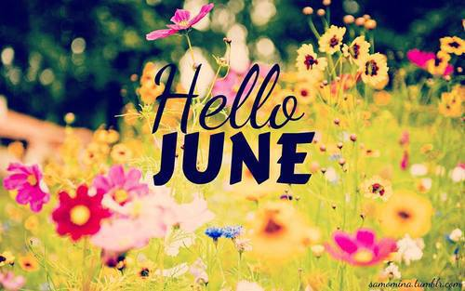**B**

**Because of the coronavirus Stay-at-Home Days**

**NW Houston IWA! meets via ZOOM**

Join us Tuesday, June 9, ***2020***

***2:00 PM***

***From Cherri Taylor***

June's meeting will be a critique session.  The pieces must be no longer than 5 double spaced pages.  Since this is a Zoom meeting, we can share the screen while we read our piece if we desire.  That is optional.

If you would like to attend this Zoom meeting, follow the link below:

Cherri Taylor is inviting you to a scheduled Zoom meeting.

Topic: NW IWA Monthly Meeting  
Time: June 9, 2020, 02:00 PM Central Time (the US and Canada)

Join Zoom Meeting

<https://us02web.zoom.us/j/4420848375>

Meeting ID: 442 084 8375  
One tap mobile  
+13462487799, 4420848375# US (Houston)  
+16699009128, 4420848375# US (San Jose)

Dial by your location  
+1 346 248 7799 US (Houston)

***2***

**Congratulations to Cherri Taylor!**

**Great Reviews**

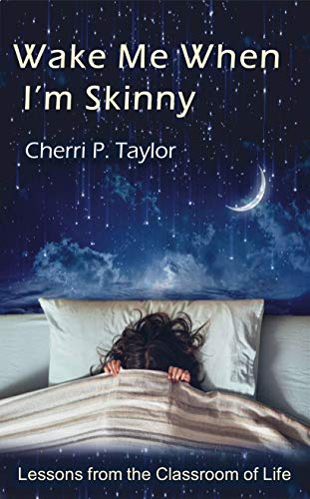

**Be sure you get your copy!**



**Staying at home gives us writing time. Contests afford writing goals. You may not win or place in a contest, but the feedback from**

**judges provides phenomenal insight into your writing. Below is a list of contests from “The Writer” newsletter.**



**Contests 3**

**Are you looking for writing contests?  
Sign up for**[***The Writer* newsletter**](https://www.writermag.com/newsletter-2/)**to get the inside scoop on our latest contest announcements.**

As you already know, *The Writer* encourages all of our readers to practice their craft and put their stories in front of the eyes of as many people as possible. Writing contests have always been a vital part of the writing world, giving writers the chance to have their work reviewed by editors and possibly published. Literary journals, universities, and even *The Writer* regularly host writing competitions, helping authors gain exposure and hone their craft.

Choose your inspiration, submit before the deadline, and, as always, keep writing.

**The Writer’s current contest:**

**2020 Spring Short Story**

**[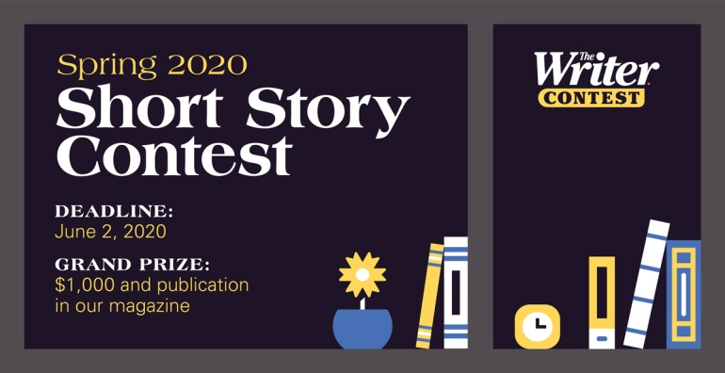](https://writermag.submittable.com/)**

Submit your best short story for your chance to win $1,000 and publication in our magazine! Any genre is fair game as long as your submission is a work of fiction under 2,000 words.

[***Submit today for your chance to win!***](https://writermag.submittable.com/)

**Need to brush up on your skills before entering the contests below?**

**For short story contests, here are a few of our favorite**[**fiction writing articles**](https://www.writermag.com/improve-writing/fiction/)**:**

* [**Win big with writing contests**](https://www.writermag.com/get-published/the-publishing-industry/win-big-writing-contests/)
* [**Editors’ tips for getting your short stories published**](https://www.writermag.com/get-published/the-publishing-industry/short-story-publishing-tips/)
* [**How to write a captivating short story**](https://www.writermag.com/improve-your-writing/fiction/how-write-captivating-short-story/)
* [**Creating fully developed fictional characters (that are not secretly you)**](https://www.writermag.com/improve-your-writing/fiction/developed-fictional-characters/)

**You can also read our**[**past writing contest winners**](https://www.writermag.com/contests/explore/past-contest-winners/)**or take inspiration from our huge collection of**[**writing prompts**](https://www.writermag.com/writing-inspiration/writing-prompts/)**.**

**UPCOMING CONTESTS**

**• [FLORAL FLASH FICTION WRITING CONTEST](https://www.writermag.com/contests/floral-flash-fiction-writing-contest-3/)**

 Deadline: 05/27/2020

**• [Lune Poetry Contest](https://www.writermag.com/contests/lune-poetry-contest-4/)**

 Deadline: 05/30/2020

**• [Dante Rossetti Awards – Young Adult Fiction](https://www.writermag.com/contests/dante-rossetti-awards-young-adult-fiction/)**

 Deadline: 05/30/2020

**• [Literary contest of Victor Voloshchuk Publishing House](https://www.writermag.com/contests/literary-contest-of-victor-voloshchuk-publishing-house/)**

 Deadline: 05/31/2020

**• [Gertrude Warner Awards – Middle-Grade Fiction](https://www.writermag.com/contests/gertrude-warner-awards-middle-grade-fiction/)**

 Deadline: 05/31/2020

**• [Inkitt Thrill Seeker Contest](https://www.writermag.com/contests/inkitt-thrill-seeker-contest/)**

 Deadline: 06/01/2020

**• [Montreal International Poetry Prize](https://www.writermag.com/contests/montreal-international-poetry-prize/)**

 Deadline: 06/01/2020

**•** [**Arizona Mystery Writers Jim Martin Memorial Story Contest**](https://www.writermag.com/contests/arizona-mystery-writers-jim-martin-memorial-story-contest/) **4**

 Deadline: 06/01/2020

**• [TreadBikely Spring 2020 Short Story Contest](https://www.writermag.com/contests/treadbikely-spring-2020-short-story-contest/)**

 Deadline: 06/01/2020

**• [2020 Killer Nashville Silver Falchion Award](https://www.writermag.com/contests/2020-killer-nashville-silver-falchion-award/)**

 Deadline: 06/01/2020

**• [Animaux fabuleux / Amazing Beasts](https://www.writermag.com/contests/animaux-fabuleux-amazing-beasts/)**

 Deadline: 06/01/2020

**• [The Writer’s 2020 Spring Short Story Contest](https://www.writermag.com/contests/2020-spring-short-story-contest/)**

 Deadline: 06/02/2020

**• [True Story Flash](https://www.writermag.com/contests/true-story-flash/)**

 Deadline: 06/03/2020

**• [Literary Taxidermy Short Story Competition](https://www.writermag.com/contests/literary-taxidermy-short-story-competition-3/)**

 Deadline: 06/04/2020

**• [Redd Tales Flagship Flash Fiction Contest](https://www.writermag.com/contests/redd-tales-flagship-flash-fiction-contest/)**

 Deadline: 06/06/2020

**• [5-7-5 Poetry Contest](https://www.writermag.com/contests/5-7-5-poetry-contest-11/)**

 Deadline: 06/08/2020

**• [Minute Poetry Contest](https://www.writermag.com/contests/minute-poetry-contest-6/)**

 Deadline: 06/14/2020

**• [Share Your Story Writing Contest](https://www.writermag.com/contests/share-your-story-writing-contest-2/)**

 Deadline: 06/16/2020

**• [Four Line Poetry Contest](https://www.writermag.com/contests/four-line-poetry-contest/)**

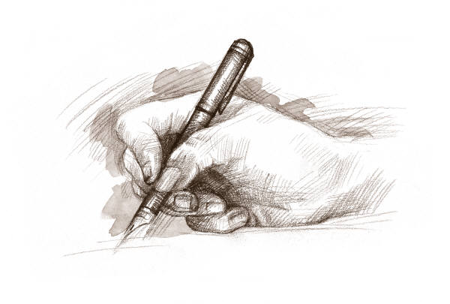

15 He sendth forth his commandment upon earth:

His word runneth very swiftly.

16 He giveth snow like wool:

He scattereth the hoarfrost like ashes.

17 He casteth forth his ice like morsels:

Who can stand before his cold?

18 He sendeth out his word, and melteth .them:

he causeth his wind to blow, and the waters flow.

**Psalm 147:15-18 KJV**

**Subscribe or unsubscribe contact: Martha Roddy/magnolia77872gmail.com**

 Deadline: 06/20/2020