

**NW HOUSTON INSPIRATIONAL WRITERS ALIVE!**

**THE SCRIBE**

***Vol. 8 July 2020 No.7_______Page 1 of 4_______***

**Christian interdenominational writers’ club. IWA! promotes creative writing to glorify Christ by helping individuals advance their writing skills and find effective Christian and secular markets for their work.**

**____________________We welcome writers at all levels.____________**

***­­Regular Meeting Location and TimeSecond Tuesdays at Copperfield Church, 8350 Hwy. 6 North, 7:00-9:00 pm.***

***Due to the Coronavirus, Regular July Meeting Canceled***



**In July and August, A ONE-TIME OPPORTUNITY for Non-Members If you love to write, submit your writing for critique to NW Houston IWA!**.

**Guidelines:**

**Times New Roman Font, Size 12 (or font and size required by your publisher); Double Space; Five-Page Limit.**

**NW Houston IWA! members publish books, essays, and memoirs. Articles and stories by Linda Slate, Marie Riffle, Debbie Sapp, Lois Harris, and Connie McWilliams’, our most prolific magazine writer, appear in magazines. Check out Amazon and Barnes&Noble for books published by Jeff Campbell, Randall Ireland, Cherri Taylor, and Martha Roddy.**

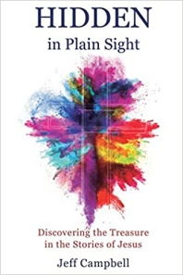 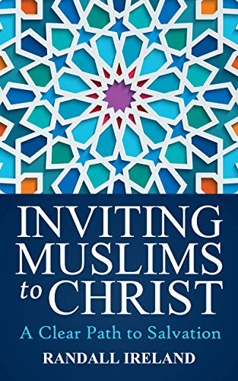 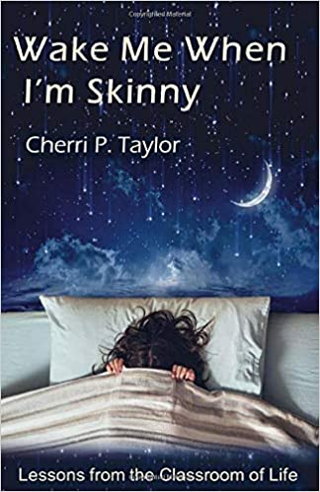 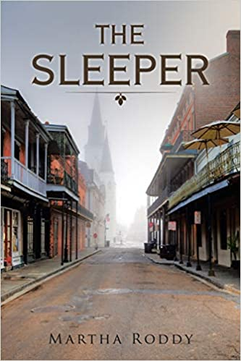

**2**

**ALL ABOUT NW HOUSTON INSPIRATIONAL WRITERS ALIVE!**



**Inspirational Writers Alive! is a statewide organization with three chapters in Houston, Pasadena IWA!, Central Houston IWA!, and NW Houston IWA!**

**The NW Houston IWA! chapter, founded in 2006, is open to new and experienced writers. Our meetings are lively with members who are dedicated to their craft. If you are looking for motivation and encouragement for writing, there is a place for you at our critique table.**

**Please visit and join NW Houston IWA!. Annual membership dues are the best deal in Texas!. If you have any questions, contact: Lois Harris, President** [lois5e@yahoo.com](mailto:lois5e@yahoo.com) **Cherri Taylor, Treasurer**[cherritaylor53@comcast.net](mailto:cherritaylor53@comcast.net)

Membership Form Below 

|  |  |
| --- | --- |
| https://lh4.googleusercontent.com/KCR52uvGOXQxKsvVdudNNQDExTqYRO0qp1XHFctGEHzDQM74k_sAAqAihwOzfDtnMcj_TnCcyK19RtJu_Gst7zWbOcbZyB-A_z8pKmlY76ZiNkOfKEY6gBpagHcmR7Dgeo5Td9Y9RgkPfdHqnA | **3**  **Inspirational Writers Alive!**  ***NW Houston IWA! Chapter Membership Application Form*** |

Other than basic contact information, only complete the blanks important to you.

|  |  |  |  |  |
| --- | --- | --- | --- | --- |
| **Name: (both names for couples)** | | | | **Date:** |
| **Address:** | | |
| **City:** | **State:** | | | **Zip Code:** |
| **Home Phone:** | **Cell Phone:** | | | |
| **Email:** | | | | |
| **Website(s):** | | | | |
| **Are you interested in being a guest speaker at our meeting in the future?** If asked, | | | | |
| **Church Affiliation:** **(optional)** | | | | |
| **Which genre(s) are you most interested in?** | | | | |
| **Membership: (check one)** | **☐ Full Membership (regular) - $25/year**  **☐ Full Membership (couples) - $35/year**  **☐ Full Membership (seniors over age 55) - $20/year**  **☐ Associate Membership - $15/year (for those unable to attend meetings)** | | | |
| **Membership Years:** | **☐2013 ☐ 2014 ☐2015 ☐ 2016 ☐** 2017    **☐**2018   **☐** 2019   **☐** 2020   **☐** 2021   **☐** 2022   **☐** 2023   **☐** 2024   **☐** 2025 | | | |
| COMMENTS AND GOALS | | | | |
|  | | | | |
|  |  | | | |
|  | | | | |
|  |  | | | |
|  | | | | |
|  |  | | | |
|  | | | | |
|  | |  | | |
|  | | | | |
| ­­­­­­­­­­­­­­­­­­­­­­­­­­­    *RECEIPT 4*  *Submit the top portion of the Inspirational Writers Alive! (IWA!) membership application form with dues to the treasurer or president of the NW Houston IWA!*  *Other current contact information can be found in the IWA! brochure, which is available upon request.* IW**A! members write in all genres, non-fiction, fiction, poetry, drama, and lyrics for the Christian and secular audiences.**  ***IWA! membership benefits include:***   * ***Attendance at any and all monthly IWA! meetings*** * ***Discounted registration for the annual Texas Christian Writers’ Conference*** * ***Discounts on entries in the annual IWA! Open Writing Competition*** * ***Monthly IWA! newsletters*** * ***Eligibility to hold an IWA! state or chapter office after one year of membership\**** * ***Full voting rights as a member of IWA!\****   ***\* Associate members are not eligible to vote or hold office.*** | | | | |
| **.**  ***Date:*** | | | | |
|  | | | | |

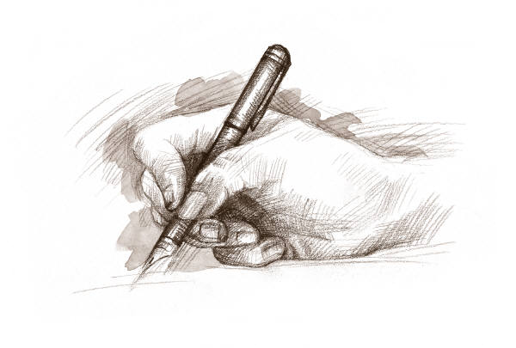

15 He sendth forth his commandment upon earth:

His word runneth very swiftly.

16 He giveth snow like wool:

He scattereth the hoarfrost like ashes.

17 He casteth forth his ice like morsels:

Who can stand before his cold?

18 He sendeth out his word, and melteth.them:

he causeth his wind to blow, and the waters flow.

**Psalm 147:15-18 KJV**

**For more information contact: Martha Roddy,** [**magnolia7787@gmail.com**](mailto:magnolia7787@gmail.com)

**Subscribe or unsubscribe** [**magnolia7787@gmail.com**](mailto:magnolia7787@gmail.com)**.**