

**NW HOUSTON INSPIRATIONAL WRITERS ALIVE!**

**THE SCRIBE**

***Vol. 9 January 2021 No. 1 _Page 1 of 3__________***

**A Christian interdenominational writers’ club, IWA! promotes creative writing to glorify Christ by helping individuals advance their writing skills and find significant Christian and secular markets for their work.**

**__________________We welcome writers at all levels.____________**



Critique Meeting

Date, Time, and Location

DATE**: January 12, 2021**

|  |  |  |  |
| --- | --- | --- | --- |
|  |  |  |  |
| **TIME: 3:00 – 5:00 PM**  **LOCATION: Cherri Taylor’s Home** | | |

**8827 Crazy Horse Trail  
Houston, Texas 77064**

**Seating Limited**

**RSVP**: **YES ONLY** by January 11  
**Phone number: 832-498-8893**

**Please observe current coronavirus guidelines for indoor meetings**

No Symptoms or Known Covid-19 Exposure; Masks: Six Feet Social Distance 

2021

NW Houston IWA! 2021Dues are due and payable in January. If you pay by check, please check with Cherri Taylor, Treasurer, for the correct “payable to” name.

**Annual Dues**

$25 Singles; $20 Seniors at 55; $35 Couples; $15 Associates (Cannot Vote)

2

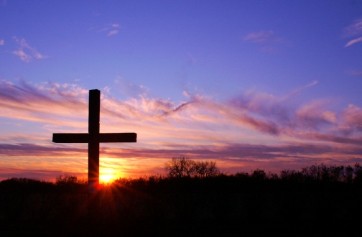

We extend their sympathy and prayers for Marie Riffle in the loss of

her husband, John Riffle. Marie. a founding member of NW Houston IWA!, recently lost her mother, Mrytle Tolley, NW Houston IWA! member.

***



Members Space for Publication!

Guidelines: Limit 1 Page Text, single-spaced for print in the Newsletter.

Limit 2-5 5 Pages double-spaced in a Newsletter attachment.



About

NW Houston Inspirational Writers IWA!

**Ask**

**Our 2021 Officers!**

Contact: Lois Harris, President [lois5e@yahoo.com](mailto:lois5e@yahoo.com)

Bronwen Spindle, **V-President and Secretary** [**bronwenbfs@gmail.com**](mailto:bronwenbfs@gmail.com)

**Cheryl Taylor. Treasurer** [**cherritaylor53@comcast.net**](mailto:cherritaylor53@comcast.net)

**Jeff Campbell, Chaplain bjcampbell@sbcglobal.net**

3

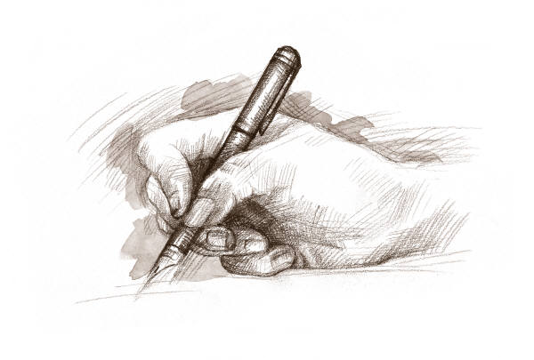

15 He sendth forth his commandment upon earth:

His word runneth very swiftly.

16 He giveth snow like wool:

He scattereth the hoarfrost like ashes.

17 He casteth forth his ice like morsels:

Who can stand before his cold?

18 He sendeth out his word, and melteth.them:

he causeth his wind to blow, and the waters flow.

**Psalm 147:15-18 KJV**

**Subscribe or unsubscribe Martha Roddy:** [**magnolia7787@gmail.com**](mailto:magnolia7787@gmail.com)**.**