

**NW HOUSTON INSPIRATIONAL WRITERS ALIVE!**

**THE SCRIBE**

***Vol. 9 February 2021 No.2 _Page 1 of 3__________***

**A Christian interdenominational writers’ club, IWA! promotes creative writing to glorify Christ by helping individuals advance their writing skills and find significant Christian and secular markets for their work.**

**__________________We welcome writers at all levels.____________**



**Critique Meeting**

**February 9, 2021**

**Location: Martha Roddy’s Home**

**7823 Green Devon Drive**

**Houston, Texas 77095**

**RSVP**: 281-859-4208 - **YES ONLY** by February 8, 2021.

**Please observe current coronavirus guidelines for indoor meetings**

No Symptoms or Known Covid-19 Exposure; Masks: Six Feet Social Distance 

**NW Houston IWA! 2021 Dues**

Due and payable in January. If you pay by check, please check with Cherri Taylor, Treasurer, for the correct “payable to” name.

**Annual Dues**

$25 Singles; $20 Seniors at 55; $35 Couples; $15 Associates (Cannot Vote)

The latest IWA! NEWS: A committee is working on the annual IWA! Conference.

The annual conferences inspires and motivates. Keep tuned and plan to attend.

2



About

**NW Houston Inspirational Writers IWA!**

**Check out our website**

**http://nwhoustoniwa.weebly.com/**

**Contact**

**Lois Harris, President** [**lois5e@yahoo.com**](mailto:lois5e@yahoo.com)

**Bronwen Spindle,** **V-President and Secretary** [**bronwenbfs@gmail.com**](mailto:bronwenbfs@gmail.com)

**Cheryl Taylor. Treasurer** [**cherritaylor53@comcast.net**](mailto:cherritaylor53@comcast.net)

**Jeff Campbell, Chaplain bjcampbell@sbcglobal.net**



3

Write to reachthe World

for Jesus

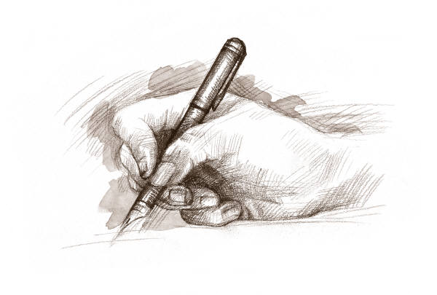

15 He sendth forth his commandment upon earth:

His word runneth very swiftly.

16 He giveth snow like wool:

He scattereth the hoarfrost like ashes.

17 He casteth forth his ice like morsels:

Who can stand before his cold?

18 He sendeth out his word, and melteth.them:

he causeth his wind to blow, and the waters flow.

**Psalm 147:15-18 KJV**

**Subscribe or unsubscribe**

**Martha Roddy:** [**magnolia7787@gmail.com**](mailto:magnolia7787@gmail.com)**.**