

**NW HOUSTON   
Inspirational Writers Alive!**

**THE SCRIBE**

***Vol.8 February 2020 No.2________________ _1 of 2***

**Inspirational Writers Alive! (IWA!) is a Christian interdenominational writers’ club. IWA! promotes creative writing to glorify Christ by helping individuals advance their writing skills and find effective Christian and secular markets for their work.**

**We welcome writers at all levels.**



**NW HOUSTON IWA! MEETS MONTHLY**

**Second Tuesdays at Copperfield Church, 8350 Hwy. 6 North, 7:00-9:00 p. m.**

**Check with the front desk for Room Number**

***Join us***

***February 11, 2020***

***Program***

***Speaker - Melanie Stiles***

Melanie has been successfully coaching individuals for many years and enjoys helping others to achieve their God-given passions. She is branded as the Life Coach in Blue Jeans due to her down-to-earth, practical, and spiritual approaches to fulfilling the desires of the heart.  Melanie has accumulated hundreds of freelance bylines, authored three books specifically for writers, and frequently speaks at conferences, churches, and with other teams/groups on topics relating to the journeys of Christian women, discipleship, leadership, biblical themes, and writing. Her award-winning book, *The Heart of a Ready Scribe: 52 Reflections for Writers*, continues to be well received by the writing community. She has completed two books of her six-part series for writers. Book One is titled: *Let’s Write! A Non-Nonsense Manual.* Book Two is titled: *Let’s Write Devotionals!* All of Melanie’s books can be found on Kindle and Amazon.

Melanie offers writing-related services to individuals and organizations, including copy creation, editing, ghostwriting, coaching, and more. Melanie is a practicing Life Coach with certifications received through the American Association of Christian Counseling. She frequently pairs with both individuals and groups to assist in goal achievement. Her coaching programs can be customized to fit specific needs.



**IWA! members learn from critique sessions, read-arounds, and speakers.**

**Save The Dates**

**2020 Meetings**

**Second Tuesdays Critique Meetings**

**March, April, June, July, September, October, November**

**2020 Upcoming Events**

**May 12 Diann Mills, Speaker**

DiAnn Mills is a bestselling author who believes her readers should expect an adventure. She combines unforgettable characters with unpredictable plots to create action-packed, suspense-filled novels.

**June 15**  **IWA! Open Competition 2020 Deadline for entries:**

For more info <http://www.centralhoustoniwa.com/>

**August 1 Texas Chrisitan Writers Conference**

Sponsored by IWA ! For more info <http://www.centralhoustoniwa.com/>

NW Houston IWA! meets at Houston’s First Baptist Church for the TCWC

**December 15** Christmas Party and Christmas Stories Read-Around

Want to be published?Submit to the “The Scribe.”

Guidelines: New Times Roman;12 point Font or Publisher Required Font; Limit 5 psges double spaced lines. Subject to Editing with Author Review and OK

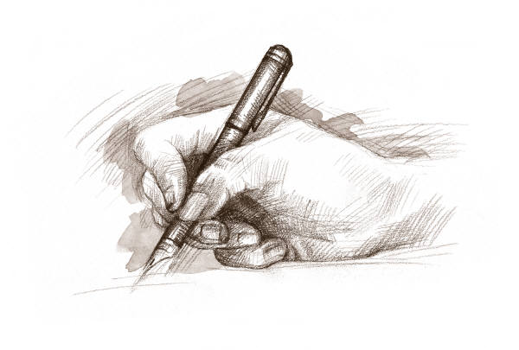

15 He sendth forth his commandment upon earth:

His word runneth very swiftly.

16 He giveth snow like wool:

He scattereth the hoarfrost like ashes.

17 He casteth forth his ice like morsels:

Who can stand before his cold?

18 He sendeth out his word, and melteth .them:

he causeth his wind to blow, and the waters flow.

**Psalm 147:15-18 KJV**

**Subscribe or unsubscribe contact: Martha Roddy/magnolia77872gmail.com**