

**NW HOUSTON INSPIRATIONAL WRITERS ALIVE!**

**THE SCRIBE**

***Vol. 8 December 2020 No. 12 _Page 1 of 3____________***

**A Christian interdenominational writers’ club, IWA! promotes creative writing to glorify Christ by helping individuals advance their writing skills and find significant Christian and secular markets for their work.**

**__________________We welcome writers at all levels.____________**

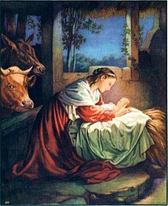

**  **

**Cancelled**

**NW HOUSTON IWA! Christmas Meeting**

**Save the date**

**January 12, 2021**

**Watch for the January 2021 Newsletter**

**With Location and Time**

**We Dedicate our December Newsletter**

**In Memory of**

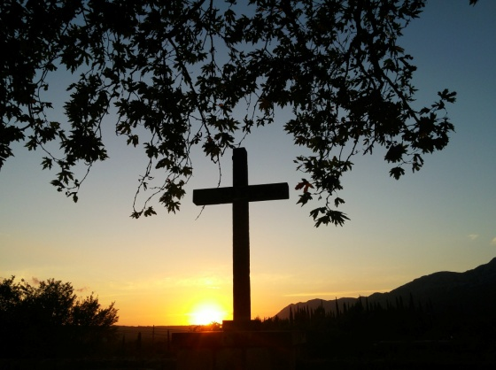

**Myrtle Smart Tolley - Houston**

**June 13, 1924 – November 17, 2020**

**Marie Riffle, Linda Slate’s mother**

**and**

**Ivor N. Gears – England**

**February 14, 1943 — November 24, 2020**

**Bronwen Spindle’s brother**





**Connie McWilliams recently published an article in Conceit Magazine**

**From Connie McWilliams**

**Published one of my stories AGAIN.  No pay, but I am out there.  I have sent off around 100 stories in October and November.  In December, I will need to get more ink for printer and large envelopes for mail off.  I am spending about 2 hours several times a week figuring out which magazines to send to.  That is what it takes. I pray I  will be published in magazines that pay in the next few months. God bless you.  Connie**

|  |  |  |  |
| --- | --- | --- | --- |
|  |  |  |  |
|  |  |  |
|  | |  |



about

NW Houston Inspirational Writers IWA!

**Ask**

**Our 2021 Officers!**

**Contact: Lois Harris, President** [**lois5e@yahoo.com**](mailto:lois5e@yahoo.com)

**Bronwen Spindle, V-President and Secretary**

[**bronwenbfs@gmail.com**](mailto:bronwenbfs@gmail.com)

**Cheryl Taylor. Treasurer** [**cherritaylor53@comcast.net**](mailto:cherritaylor53@comcast.net)

**Jeff Campbell, Chaplain bjcampbell@sbcglobal.net**

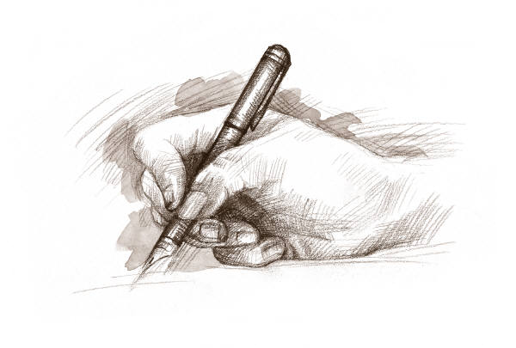

15 He sendth forth his commandment upon earth:

His word runneth very swiftly.

16 He giveth snow like wool:

He scattereth the hoarfrost like ashes.

17 He casteth forth his ice like morsels:

Who can stand before his cold?

18 He sendeth out his word, and melteth.them:

he causeth his wind to blow, and the waters flow.

**Psalm 147:15-18 KJV**

**Subscribe or unsubscribe Martha Roddy:** [**magnolia7787@gmail.com**](mailto:magnolia7787@gmail.com)**.**