

**NW HOUSTON INSPIRATIONAL WRITERS ALIVE!**

**THE SCRIBE**

***Vol. 8 August 2020 No.8 ____Page 1 of 2_______***

**A Christian interdenominational writers’ club. IWA! promotes creative writing to glorify Christ by helping individuals advance their writing skills and find effective Christian and secular markets for their work.**

**____________________We welcome writers at all levels.____________**

**Today is the Day**

**To Learn**  ******Something New**

**Try writing!**

**Inspirational Writers Alive! a statewide organization, has three chapters in Houston. NW Houston IWA! chapter meetings are lively with members who are dedicated to their craft and write fiction, non-fiction, short stories, essays, memoirs, and lyrics.**

**Interested? Visit our website [nwhoustoniwa.weebly.com or contact](http://nwhoustoniwa.weebly.com/)**

Martha Roddy at **magnolia7787@gmail.com.**



**There is a place for you at our critique table. See Below.**

**Articles and stories by Linda Slate, Marie Riffle, Debbie Sapp, Lois Harris, and Connie McWilliams’, our most prolific magazine writer, appear in magazines.**

**Check out Amazon, Barnes&Noble, Walmart, Target, or your favorite book store online for books published by NW Houston IWA! members Jeff Campbell, Randall Ireland, Cherri Taylor, and Martha Roddy.**

   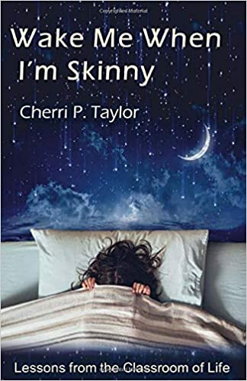 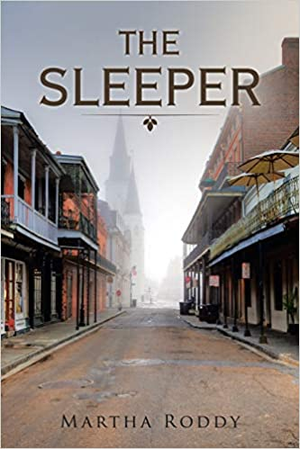

**If you have questions, contact: Lois Harris, President** [lois5e@yahoo.com](mailto:lois5e@yahoo.com) **Cherri Taylor, Treasurer**[cherritaylor53@comcast.net](mailto:cherritaylor53@comcast.net)



15 He sendth forth his commandment upon earth:

His word runneth very swiftly.

16 He giveth snow like wool:

He scattereth the hoarfrost like ashes.

17 He casteth forth his ice like morsels:

Who can stand before his cold?

18 He sendeth out his word, and melteth.them:

he causeth his wind to blow, and the waters flow.

**Psalm 147:15-18 KJV**

**For more information contact: Martha Roddy,** [**magnolia7787@gmail.com**](mailto:magnolia7787@gmail.com)

**Subscribe or unsubscribe** [**magnolia7787@gmail.com**](mailto:magnolia7787@gmail.com)**.**