

**NW Houston Inspirational Writers Alive!**

**THE SCRIBE**

APRIL 2020 SPECIAL___1 of 3_______________ **Inspirational Writers Alive! (IWA!) is a Christian interdenominational writers’ club. IWA! promotes creative writing to glorify Christ by helping individuals advance their writing skills and find effective Christian and secular markets for their work.**

**We welcome writers at all levels.**



HE IS RISEN!

Verily, Verily, we’ll never forget on Good Friday and Easter Sunday 2020, commemorating the crucification and death of Jesus on Calvary, and His resurrection. At home - *we know* ***t****he eyes of the Lord are in every place, beholding the evil and the good.*Proverbs 15:3.

God is with us. In Jerimiah 23:24-25, we read *Am I a God at hand*, sa*ith the Lord, and not a God afar off?* *Can any hide himself in secret places that I shall not see him? saith the Lord. Do not I fill heaven and earth? saith the Lord. Jeremiah 23:29 declares Is not my word like as a fire? saith the LORD; and like a hammer that breaketh the rock in pieces?*

Always blessed, we are apart and together during Easter week this year. NW Houston IWA! is grateful for two loyal members and their publications this Easter month. Scroll down for the good news.

2

  
Congratulations!

Cherri Taylor and Connie McWilliams

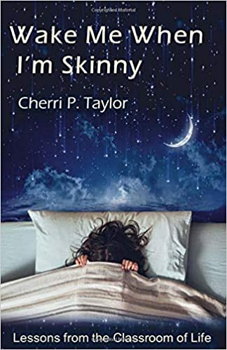

Cherri Taylor’s book is available at Amazon and your favorite book stores.

Check it out. <https://www.amazon.com/Wake-Me-When-Skinny-Classroom/dp/B086LDRL86/ref=sr_1_1?dchild=1&keywords=Wake+Me+When+I%27m+Skinny&qid=1586364952&sr=8-1>

Connie McWilliam’s HUG GOD is scheduled for the APRIL, 2020 issue of THE ENCHANTED FILE CABINET ONLINE SHORT STORY MAGAZINE (which will go live tomorrow (April 11Town ) and the JULY, 2020 issue of CONCEIT MAG.

At home? You better be! Seeking curious, energetic, kind, friendly, joyful, optimistic,confident, frank, loving words?. Read Cherri Taylor and Connie McWilliams!

3



NW HOUSTON IWA! will not meet as scheduled on April 14, 2020.

We’ll play it by ear and follow the guidelines about our May meeting.

Stay Tuned!

STAY AT HOME

KEEP SAFE

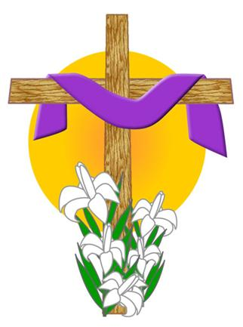

A BLESSED EASTER FROM ALL OF US AT

NW HOUSTON IWA!

Subscribe or unsubscribe - Martha Roddy magnolia7787@gmail-com.