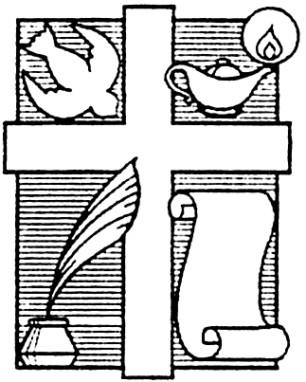
Inspirational Writers Alive!
Speaker Registration Form

Thank you for your interest in speaking at an IWA! meeting. Please complete and return this form to Martha Roddy at magnolia7787@gmail.com or 7823 Green Devon Drive, Houston, Texas 77095. Feel free to include additional published works, possible speaking topics, and biographical information on the back of this form or as an attachment.

Name: __________________________________________________________________ Date: _____________________
Address: __________________________________________________________________________________________
City: ___________________________________________ State: __________________ Zip Code: __________________
Home Phone:_____________________________________ Cell Phone: _______________________________________
E-mail: ____________________________________________________________________________________________
IWA! member (if yes, please indicate chapter): Yes No ____________________________________________
IWA! chapter(s) you would like to speak for: _____________________________________________________________
Author Status (please circle one): Not yet published Published by a Traditional Publisher Self-published
Titles of Published Works: ____________________________________________________________________________________________________________________________________________________________________________________________________
Possible Speaking Topics:
Topic 1
Subject: ___________________________________________________________________________________________
Title: _____________________________________________________________________________________________
Summary: ____________________________________________________________________________________________________________________________________________________________________________________________________
Topic 2
Subject: ___________________________________________________________________________________________
Title: _____________________________________________________________________________________________
Summary: ____________________________________________________________________________________________________________________________________________________________________________________________________
Short Bio (150-200 words): ______________________________________________________________________________________________________________________________________________________________________________________________________________________________________________________________________________________________________

Rev. 01-2013

